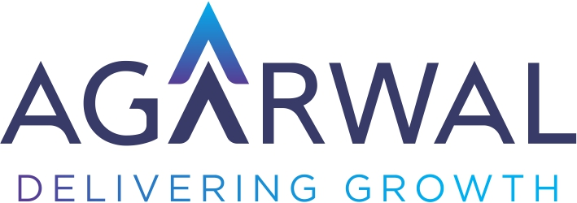

Job Profile:Branch operation
Position Holder’s Name | Deva Ranjan Pattnaik | w.e.f. | 01-04-2022
Qualification | MBA Finance | Total exp | 6 Year
IT Skills Required | N.A | Reporting Manager | Nitin Agarwal/Pankaj Agarwal
DOB: | 14th MAR 1993 | On Roll | Branch Accountant
DOJ: | 10TH MAY 2021 | Location | Rourkela

Job Summary: Branch Accounting, SAP Operation, Documentation

Job Description:

KRA-1 Branch Accounting
- 1. Mining details Collection, Daily MCL Sheet Update
- 2. Order wise Debit/Credit Note preparation based on the contract/sales order.
- 3. Prepare monthly reconciliation of Costumer ledger.
- 4.Maintaining customer payments tracker'
- 5. Entry of payments received from the customers on daily basis in SAP & circulating the report with branch operations team.
- 6. Providing support for branch internal audit
- 7. Daily Bill Generation for customers and vendors and ensure that the bills are received by the customers
- 8. 27C form Collection and sending it to corporate office
- 9. PDC collection, Cr limit issue as per order.
- 10. Costumer excess payment refund
- 11. Visiting government departments as & when required.
- 12.Invoice copy arrangements.
- 13.Commission bill processing.
KRA-2 SAP Operations
- 1 Preparation of SO/PO as per contract &. Do release
- 2. Daily IRN check, Sale Register check ,ledger check

- 3. GRN entry, GRN reverse Entry, Stock Transfer Entry, Closing Balance Match
- 4. Sale invoice, Eway bill preparation
- 5. Update cash voucher and Card expanse in SAP
- 6. Timely entry of GST invoices in SAP
- 7. Generate Accounts related MlS from SAP and circulate as required.
- 8. inspection of vendor bills for if any corrections.

KRA-3 Other works
- 1 Responsible for collecting new customers KYC related documents, completing customers /vendor registration in SAP and coordinating with corporate office for approval
- 2 Maintain and checking of customers Purchase order and Contracts
- 3. Coordination with costumers, Marketing Manager, other branches and HO management on regular basis

